Address: Cornwallis Road, Oxford OX4 3NH
Web: www.florenceparkcommunitycentre.org.uk
Tel: 07864 028591
Email: florenceparkcommunitycentre@gmail.com

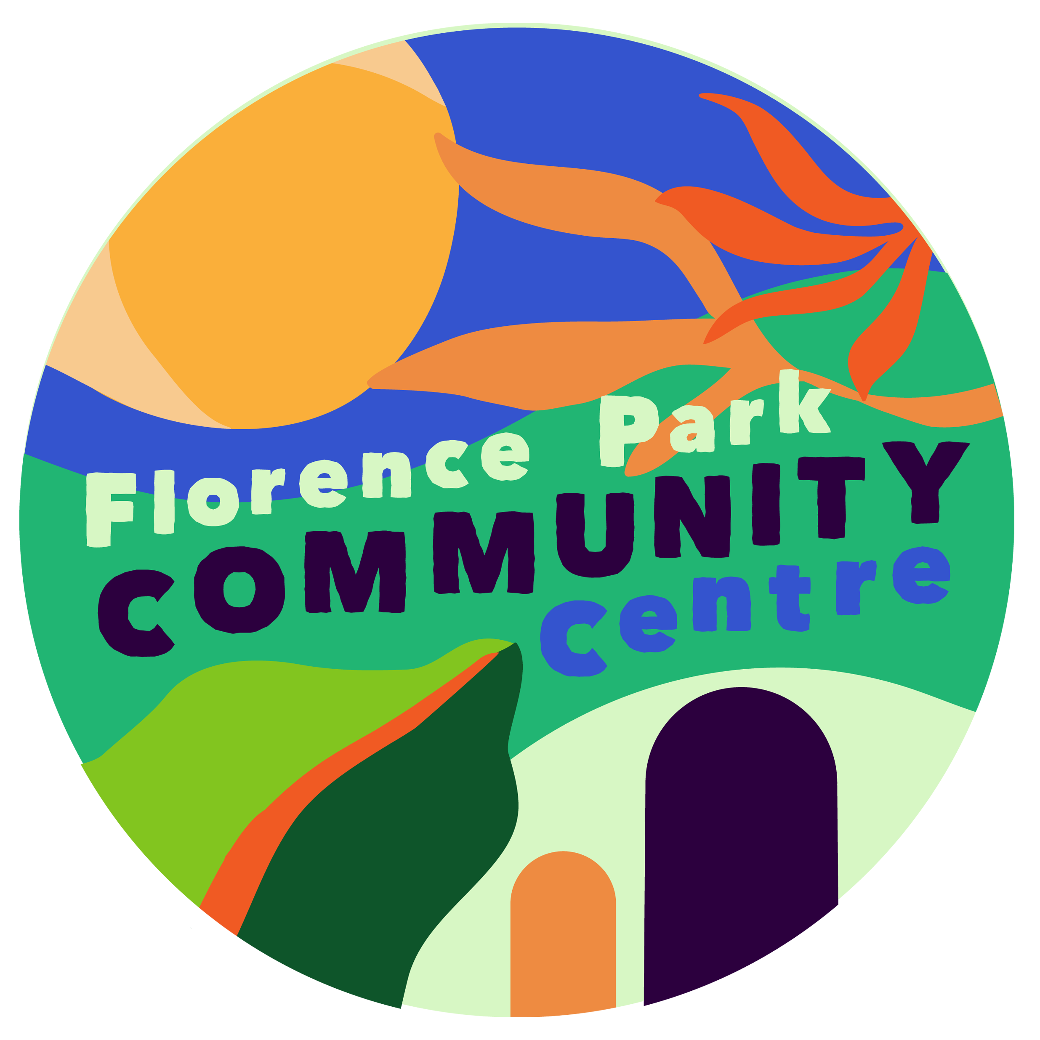
Application for Membership
I apply for membership to the Florence Park Community Association and Social Club and agree to abide by the FPCA constitution and Social Club rules.

I am 18 years of age or over I am under 18 years of age
I have never been banned from any community centre, club or licensed premises.
Date: ___________________________
I am applying for:
FULL MEMBERSHIP (Residents of Florence Park area 18 years of age or older) OR
JUNIOR MEMBERSHIP (Residents of Florence Park area younger than 18 years) OR
ASSOCIATE MEMBERSHIP (If you live outside Florence Park area of benefit but support FPCA charitable objects – see over page)
Tick here if you do not want to join the Florence Park Social Club which runs the bar in the evenings (if you do not opt out members will join both the Community Association and the Social Club. Junior members may not join the Social Club so will automatically be opted out)

As a: FAMILY / SINGLE / SENIOR CITIZEN (circle one category)
For family membership, please enter both of the adults’ names. Please USE BLOCK CAPITALS

Name 1: Mr/Ms/Mrs/Miss/Mx __________________________________________________________

Name 2: Mr/Ms/Mrs/Miss/Mx ____________________________________________________________

Address: _____________________________________________________________________________

_________________________________________________________ Postcode: _________________

Email: ___________________________________________________ No. of children ______________

Please tick if you DON’T want be added to the Association’s email list.

Annual Membership fees** | New Members | Members who opt out of social club and Junior members
Individual | £6 | £5
Family | £10 | £8
Seniors (over 65)* | £2 | £1
Membership application process:
Membership is at the discretion of the FPCA committee. Please give your application form and the membership fee to any management committee member or leave with the bar staff. Membership cards are prepared by the membership secretary and they can be picked up any evening from the bar or by arrangement. Membership is for the year from 1 April to 31 March regardless of the date of joining but members have until the end of June each year to renew their membership.
*Seniors as of 2018 with over 5 years’ continuous membership will receive free membership but must renew it each year through submission of their old membership card and receiving a new one
The Florence Park Community Association membership:
- FULL MEMBERS may vote at the FPCA AGM and are charged the local room hire rates.
- JUNIOR MEMBERS are charged the local room hire rates. They may not vote at the FPCA AGM but are given the special right to elect up to 2 advisers to attend trustee meetings as observers.
- ASSOCIATE MEMBERS will be invited to elect two representatives to vote on their behalf at the FPCA AGM and are charged the associate room hire rates.
Florence Park Social club membership:
- FULL AND ASSOCIATE MEMBERS may vote at social club AGM and participate in social club events.
- JUNIOR MEMBERS of the FPCA may not join the social club.

The FPCA charitable objects
The objects of the Association are to:
(a) promote the benefit of the inhabitants of Florence Park Estate and the neighbourhood together defined by the area bounded by the Oxford Road, Between Towns Road and Church Cowley Road (including Eleanor Close), Henley Avenue, and the Boundary Brook. (hereinafter called "the area of benefit") without distinction of sex, sexual orientation, race or of political, religious or other opinions, by associating together the said inhabitants and the local authorities, voluntary and other organisations in a common effort to advance education and to provide facilities in the interests of social welfare for recreation and leisure-time occupation with the object of improving the conditions of life for the said inhabitants;
(b) establish, or secure the establishment of, a Community Centre (hereinafter called "the Centre") and to maintain and manage the same (whether alone or in co-operation with any local authority or other person or body) in furtherance of these objects.
(c) promote such other charitable purposes as may from time to time be determined.
The Association shall be non-partisan in politics and non-sectarian in religion.

The full FPCA constitution and the Social Club rules are available on our website
www.florenceparkcommunitycentre.org.uk

