Florence Park Community Association

Re-opening survey results

Thank you to everyone who completed our survey about the re-opening of the Community Centre. We had a fantastic response with a total of 92 completing the survey. This helps us get a clear picture of how our community feels about the Centre re-opening and what things you would like us to do.

Headline results:

- 53.9% of respondents were very likely or likely to use the Centre once the Centre is allowed to open following government guidelines.

- Bar and café were the most preferred activities or events, with 51.1% and 52.3% support for each one. 37.5% would use classes, and 28.4% would use meeting rooms.

- 50% are happy to come to events at the Centre making their own assessments of the risk, whilst 32.2% will come to the Centre if social distancing procedures are strict and rigorously enforced. 18% are reluctant to come, and 26.7% will not attend if toilets aren’t available.

- 80.3% of respondents are very likely or likely to attend events held in our outdoor space.

Full results:

Closed questions
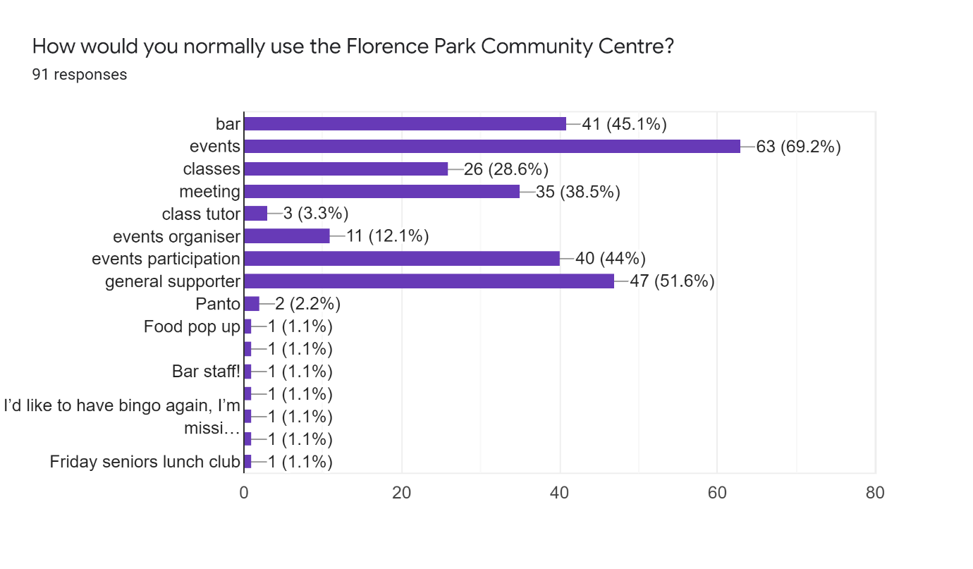
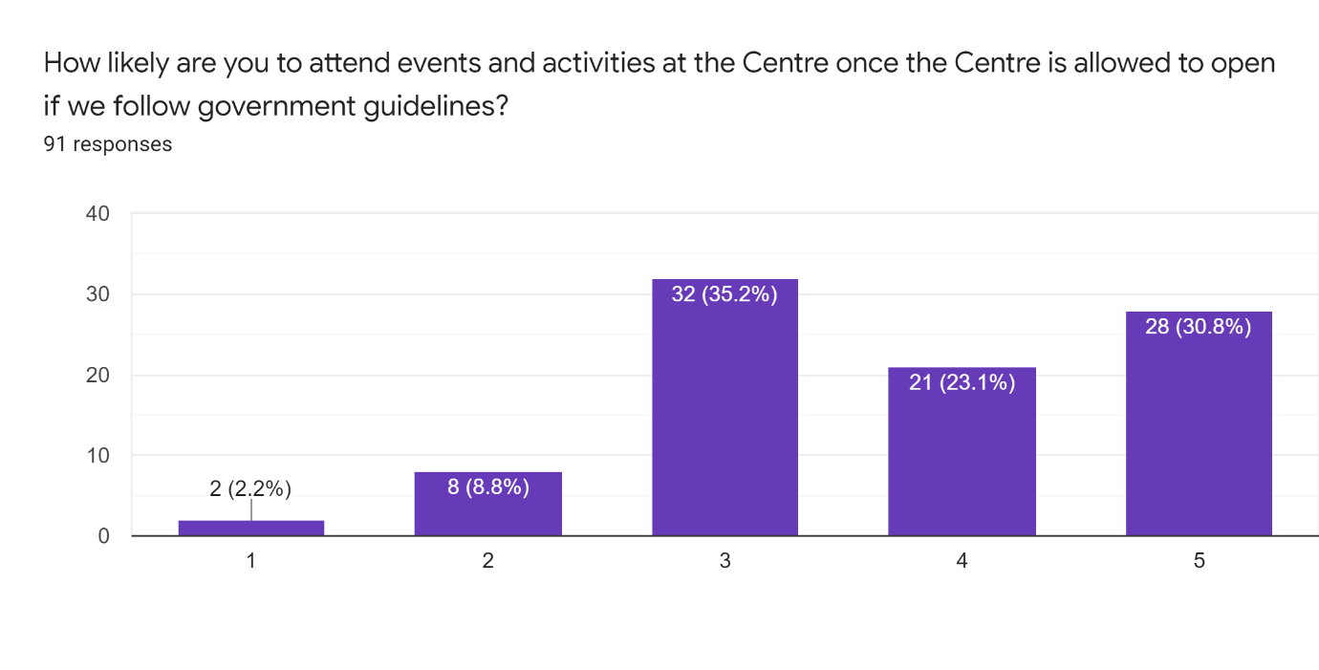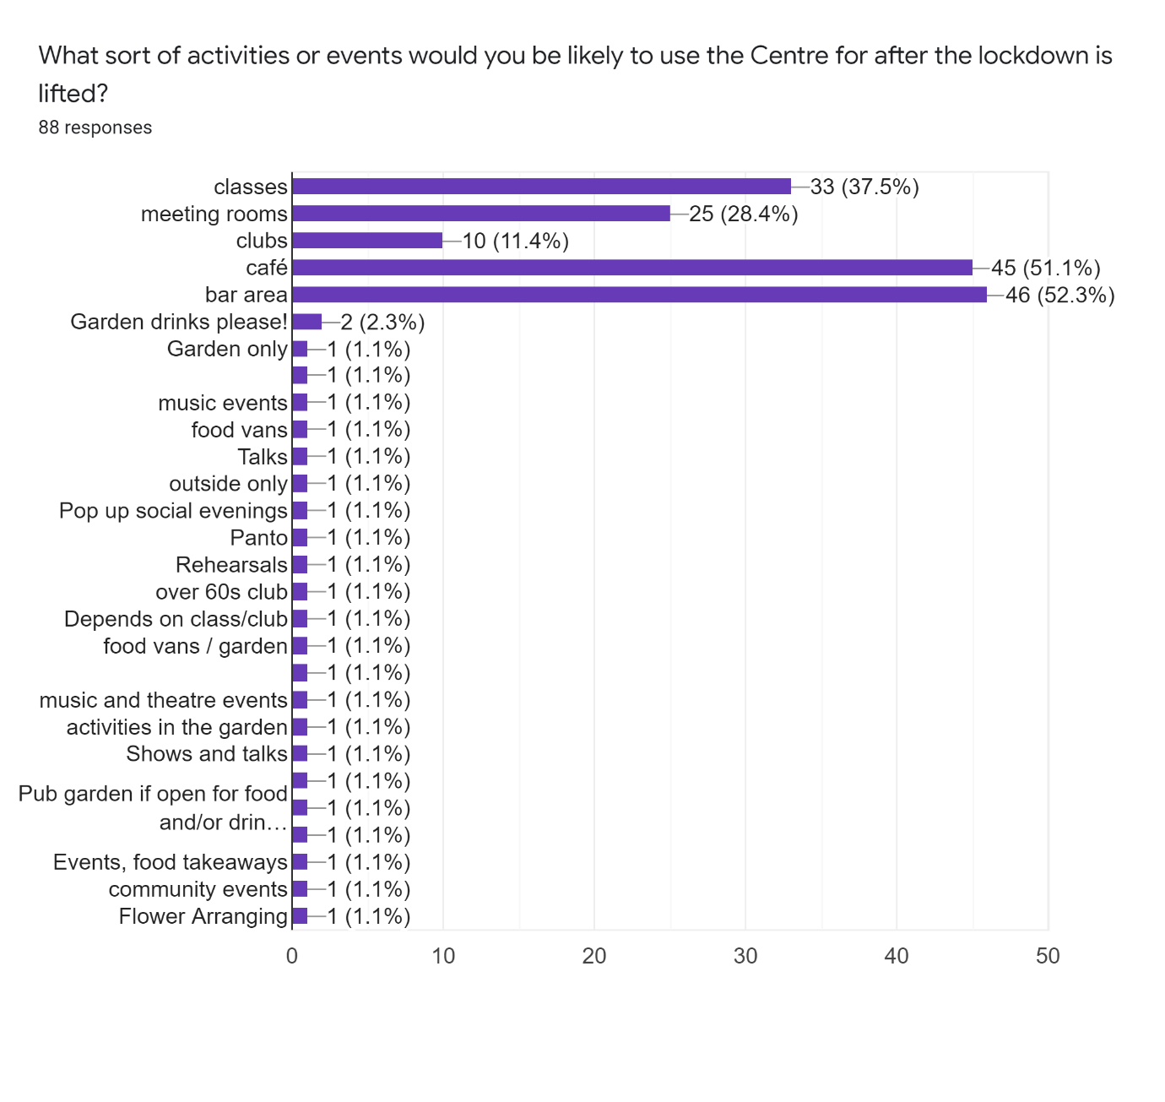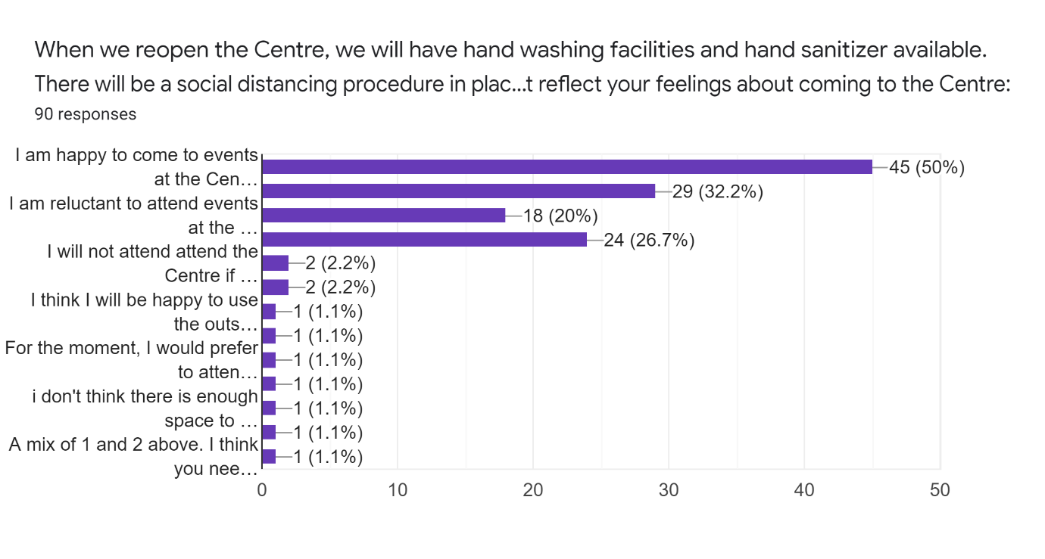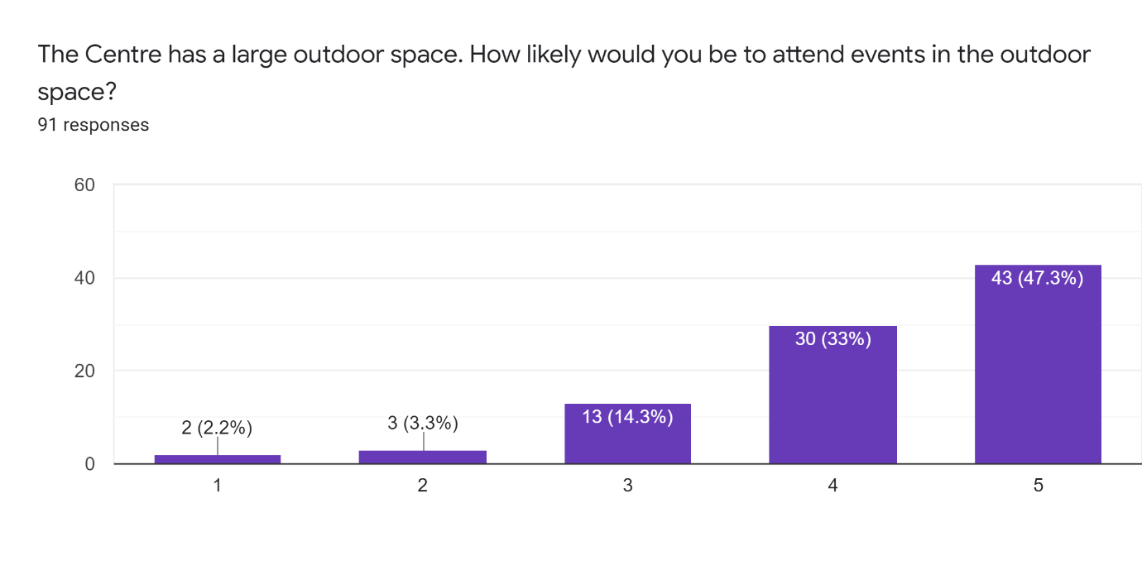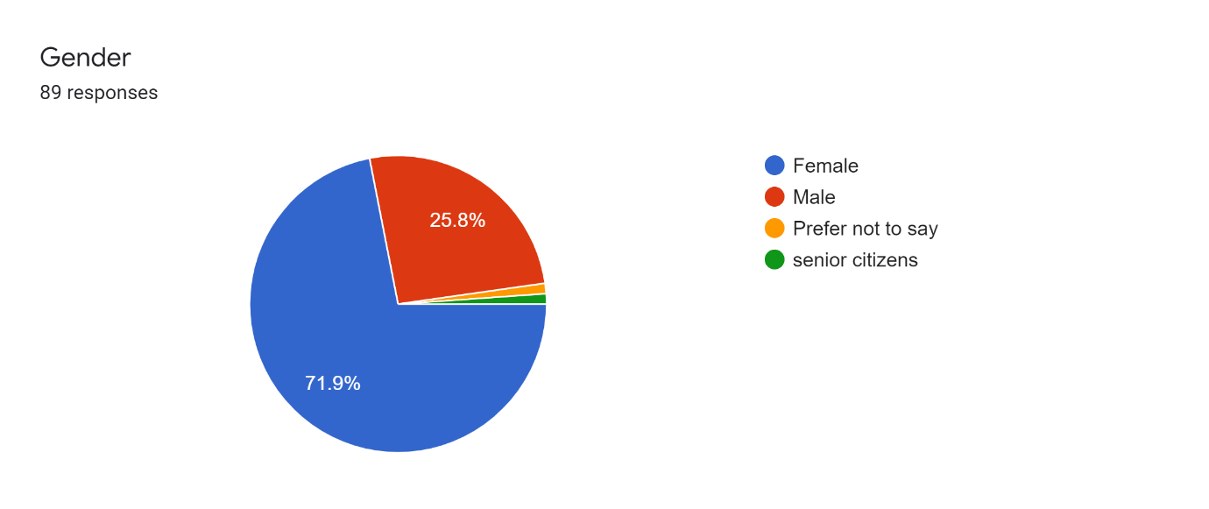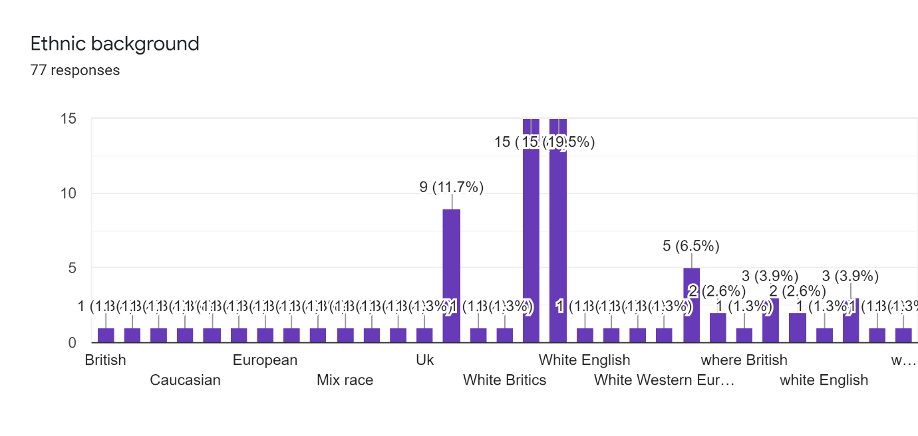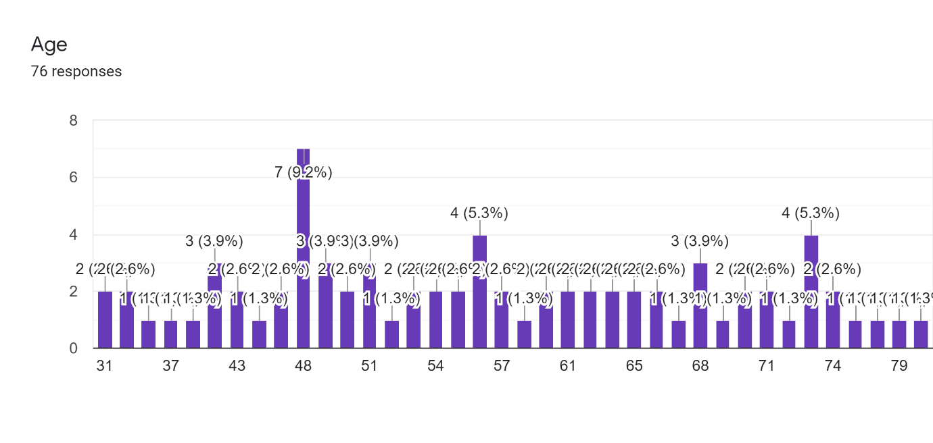

Replies to open-ended questions:

Are there any activities generally that you have taken an interest in since the lockdown began (e.g. gardening, baking, jogging, yoga, etc.)?56 responses
gardening
Gardening and cooking.
All of the above
No
Baking, walking
None
Baking, tai chi and Pilates online, singing (online choirs), learning Italian...
Gardening
I'd love an exercise class at the centre! Especially like glow in the dark disco/club aerobics type fun :+)
No
Gardening, baking, wifi whinging, online dance
Gardening, yoga
Exercise, cooking, online meetings and events.
Gardening and I need some gentle exercise as I cant go to dance clubs at the moment.
neighbourliness
Fitness classes
Walking and learning to identify birds, plants etc.
Gardening , art/DT
Baking. Running.
gardening, jogging
Gardening, baking, jogging
I use Blackbird Let's for classes. No new skills here!
Gardening, knitting
More neighbourly social distanced get togethers
Gardening
Panto skills
learningguitar, Zumba
DIY etc
Yoga
no
knitting!
French conversation
Online HIIT
Gardening and baking
Allotment and running meditation groups-online, writing music
Gardening, theatre
gardening, yoga, dancing, protests, environment, women's discussions, acting, events
jogging, baking, yoga, gardening
No I have not stopped working
Haven't started anything new - already had too many activities to keep up with!
Gardening veg in containers/Basic baking and easy meals from scratch
not specifically
Gardening, running
gardening, BLM
gardening, baking
Growing veg, walking lots
none in particular
variety show; quiz; Flo/Glo Fest
zumba
Crochet and more gardening and baking
Baking

Have you taken part in any of the FPCA online activities during the lockdown? Which ones?67 responses
No
no
Virtual variety night. And glofest
Variety night
Flofest
Bingo, Variety Night
Variety show
Family Quiz and various Zoom calls
Writing poems and stories
Some
Sorry, I was away, but joined in Emily's choir for Flofest, and watched some of the event online..Going back to Oxford this weekend (12/07) so will be very happy to rejoin my community!
variety night
Book group
Glo-fest virtual, lockdown showdown
Facebook Live cooking show, Bingo, Quiz nights
N/A
Flofest; Cooking with Mondy; Friday photos
Watched Flofest & Variety show
variety night, flofest
Virtual Variety Show! Mondy’s Cooking
Variety show was fun
FloFest
No I’m not online I rely on my daughter for things like this
Talent and dog show
Bingo, quiz, variety event, festival, Saturday lockdown, Mondy,s cooking
Mondy cooking. Book ckub/ poetry
Virtual Variety Night, Quiz
No (was not aware of any)
Choir
quiz
As audience during the variety club evening
not so far
Bingo!
No...not so happy doing more online things...
Zoom meetings and webinars, on-line learning cousre
Poetry, 'What I see from my front window'
watched variety show
Yes v v n and bingo
No , unless GloFlo counts
Watched Variety night in May, watched and took part in Virtual FloGlo.
I watched the online variety night
Variety night & flofest
Watching Flo Fest
Watched virtual variety night, Bingo
Virtual variety night, FloGlo, bingo
quiz; variety show; Flo/Glo Fest
No
Yes, Mondy's Cooking, Tuesday Thoughts and the Isis Care home letter

Do you have any suggestions or recommendations for how we could use the outdoor space for post-lockdown events?48 responses
I’d love to run the women’s networking group.
Beer garden
Drinks, social, quizzes etc.
Pop Up Socials ... small music (solo/duet) performances ... aunt sally
No
Perhaps allow only a limited number of people attending events, or marking areas for small groups with a sensible space between them?
Book group? Singing -- when it's allowed?
bring yer own picnic
Be prepared for a second spike- keep virtual events going alongside . Make best use of outside space for now.
Out door cafe, drinking area, markets
Show football and rugby matches on a big screen. Much better vibe than pubs.
Concerts using mask if there will be children and alcohol involved
Maybe use some gazebos ( no sides) or tarpoling to create shade/ shelter in different areas
Rain and wind proof!
Summer afternoon chill parties with acoustic music / cookery demonstrations/entertaining brief talks/ and food brought to the tables/picnic blankets. Physicially distanced community singing for fun.
I would love to hear live music, would be nice to feel with people again
Cafe tables when the weather is good?
Outdoor bar seating.
Elderly coffee chats/get togethers
Afternoon picnic with bar
Bar/meals with restricted numbers
Model Garden and outdoor cafe.
Country dancing or similiar - likely to be for everyone, children, singles, couples, elderly
Outdoor theatre
Small gatherings, birthdays etc
Cafe
Family picnics
Outdoor bar / cafe
No
outdoor variety night / plays/ quizzes
World food / culture fair? (Talks, music, food, dance)
Pop up restaurants and take-away, outdoor gigs, family-friendly events.
If the grass is kept trim, the space would be good for holding exercise classes outdoors - when the weather allows!
Bring your own Teddy Bear Picnic for Adults and for Children. We all have Teddys.
Possibly take away food van. Table service drinks.
Music, cafe, bar
It would be nice to see events in the garden - te Friday pop up food events could work well there.
1) Family games day - teams compete in round robin events of several different games - e.g. aunt sally, badminton, table tennis, darts, tiddlywinks, giant jenga... 2) Open mic afternoon in the sunshine 3) bbq 4) gardening club 5) outdoor horticultural show 6) mini festival 7) Spooky halloween event
classes
Cafe/takeaway food. Variety performances. Games, outdoor film nights. Obviously everything is weather dependant and an investment in gazeebo’s, umbrellas etc would be a good idea
Barbeque; Dog Show; Outdoor quiz; Variety Show; Music
cafe, classes
table top sales
Table service bar
Markets

What would you like to see from the FPCA in the future?35 responses
Any activities that you can provide safely.
Open! Xxx
To be back helping support the community with events, classes and other opportunitrs to engage
Yes
Hope it will go back to the normal range of activities very soon...as long as there is no new surge of the virus....
Depends how things go on?
organise activities in the park
Make the outside space really lovely team up with Flo’s , city farm , restore, ark t in rotating collaborative events?
A consuidered and gradual approach to re-opening the facilities.
More Sunday Sessions and music
Social events
More inclusion across the estate.
more integration of the wide range of communities in the area, develop links with different communities
Opportunities to meet new people as I've only recently moved here. Before lockdown I was happy to plonk myself down and introduce myself. That won't really be possible now so events enabling those of us who live alone would be great.
Continue to support people who need to continue to isolate, even when things begin to look a bit more 'normal' for most. You've been brilliant at supporting the whole community during lockdown.
Back to normal activities if posdible
Christmas events/shows; social events but very socially distanced and outside
saturday cafe, over 60s club
Cyclists - cycle maintenance lessons/facilities
Off hand, can't think of anythink to add.
You are doing amazingly well as it is!
I am more likely to want to run a meditation group focussed on restoring ourselves and the planet, and/or a singing group than be a participant....re-jigging my life post covid
Place for parents with young children to meet, as all stay and play type things are closed. Just a cafe environment, indoors or out. Or a place for people to sit indoors on picnic blankets, with their own toys, if it is too cold to picnic outside.
Music, drama, comedy events
Zumba.Panto. variety shows, impro shows (if feasible)
more whole community led events
Ways to support inclusivity : ethnic minorities , immigrant population.
Love it as it is!
Think you are doing a brilliant job for the community. Can't think of anything.
I hope many local activities can resume but not rush it as we don't know enough.
More entertainment events - plays, shows, bands
Politics Week quiz if okay to run it this year; more great gigs like Islet - they were excellent
Outdoor theatre
Are there any parts of the community you think the FPCA should be engaging more with? How do you think we can target these areas?33 responses
We all need to make an effort to actively reach out to bame communities
Engage with street champion network locally as a way to reach everyone - especially those in need.
No
Sorry, not sure what is needed to engage with the whole of Florence Park. I think personal contacts by members with residents who do not use the centre normally work sometimes, as well as good publicity...
Asian community and multi generational activities
What can we learn from the Black Lives Matter Movement - and how might the BAME be part of the conversation in the activities of the centre.?
Teenage activity is under represented
More diverseity in participation but no idea how!
People with kids getting free school meals. Unemployed folk.
more of a class and ethnic range. reach out to community leaders to find out what they think, maybe put on joint events
Kids!
Singles (but not in a dating sense!)
I’m elderly and all things I attended, Zumba, bingo lunch club have all been shut down, I have very little interaction with anyone my own age. I’m also not online so have felt very excluded and rely on my daughter to keep me informed
People newly alerted to community due to virus
I think FPCA does a great job of engaging with lots of different elements of the community.
I'm not completely aware of areas/groups that FPCA is targetting, so can't really comment.
Not really, you seem to have it covered.
BAME community....let them know they can use the space for their own activities, gatherings?
New parents/young children. Just give them the opportunity to meet at your venue if they feel comfortable with the risk. So much is still closed for children.
Ethnic minorities
Asian people - don't know how but they might have suggestions
yes, the different cultures. maybe good to invite representatives from different communities to explore how/ if they would like to be included
Recent (Last 10-15 years) migrants, esp those in shared houses but also those in family units. These people may not ‘get’ the typical events organized. Best way to target could be with some semi-structured interviews about situations, needs, languages, likes/dislikes That would stop people coming (eg Is alcohol , certain foods, certain behaviors ?). Maybe a local Uni Dept could help with students to ask questions?
Don't know
Contact those without technology to find out their views. At moment it is very unfairly balanced and these people have to go along with those who have campaigned/requested whi do have technology. Footfall on doorsteps would be welcome.
I think you've done brilliantly so far
To engage with groups not currently using the facility it might help to go through someone who is part of that group and get them to help set up an event or join the committee.
It would be good to see more events and activities aimed at BAME communities, led by those communities.
Youth by linking up with City Farm & youth associations. Mental health. Perhaps working with Elder Stubbs and offering and developing a well being garden for mental health in the garden area?
You seem to be doing a very good job of engaging with everyone
Children's computer club
Pre teens and young adults - maybe enable them to organise their own 'events' with your support

